**CENWP-OD-B 08 September 2023**

**MEMORANDUM FOR THE RECORD**

**SUBJECT: 23BON088 MFR AFF Valve 15 Salmonid Mortalities**

In the morning of 07 September, Columbia River Inter-Tribal Fish Commission (CRITFC) Biologists notified Bonneville Project Biologists of six salmonid mortalities found on the Valve 15 trash rack in the Adult Fish Facility (AFF). The fish were all scanned for PIT tags, inspected, and returned to the river.

#1

1. 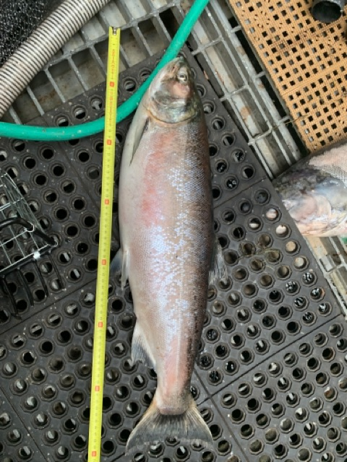Species – Salmonid (*Oncorhynchus spp)*
2. Origin – Unknown
3. Length – 71 cm
4. Marks and tags – Adipose fin clip, no PIT tag
5. Marks and Injuries found on carcass – General decay.
6. Cause and Time of Death – Unknown
7. Future and Preventative Measures – None

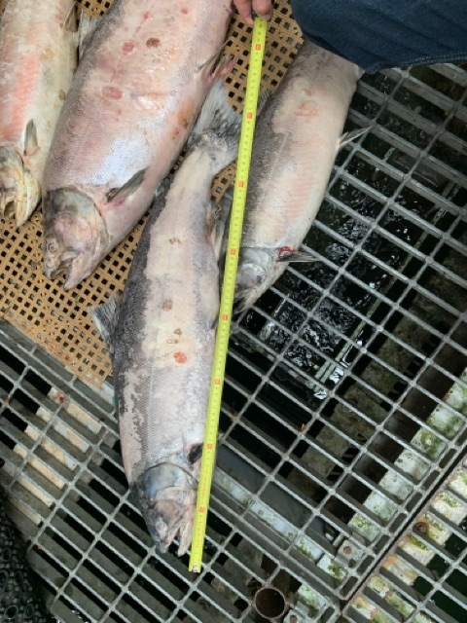#2

1. Species – Salmonid (*Oncorhynchus spp.)*
2. Origin – Unknown
3. Length – 68 cm
4. Marks and tags – No PIT tag
5. Marks and Injuries found on carcass – General decay, descaling, discoloration.
6. Cause and Time of Death – Unknown
7. Future and Preventative Measures – None

#3

1. Species – Salmonid (*Oncorhynchus spp.)*
2. Origin – Unknown
3. Length – 55 cm
4. Marks and tags – No PIT tag
5. Marks and Injuries found on carcass – General decay, descaling, discoloration.
6. Cause and Time of Death – Unknown
7. 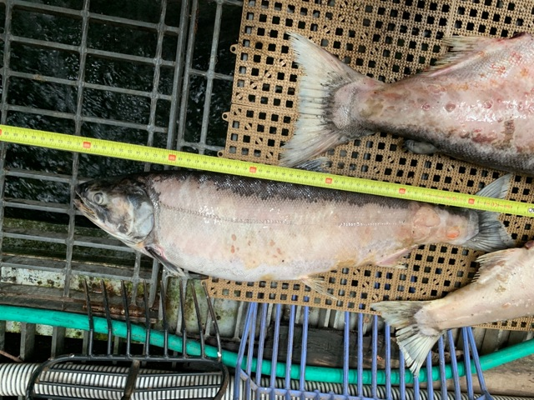Future and Preventative Measures – None

#4

1. Species – Salmonid (*Oncorhynchus spp.)*
2. Origin – Unknown
3. Length – 60 cm
4. Marks and tags – No PIT tag
5. Marks and Injuries found on carcass – General decay, descaling, discoloration.
6. Cause and Time of Death – Unknown
7. 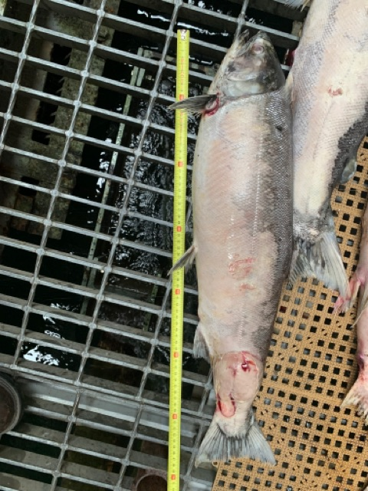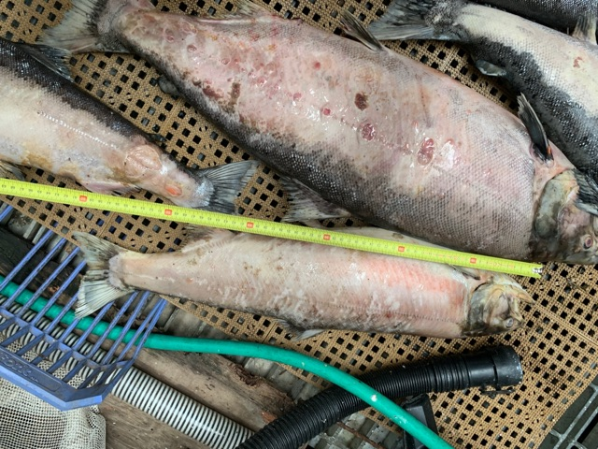Future and Preventative Measures – None

#5

1. Species – Salmonid (*Oncorhynchus spp)*
2. Origin – Unknown
3. Length – 68 cm
4. Marks and tags – Adipose fin clip, no PIT tag
5. Marks and Injuries found on carcass – Advanced decay, hemorrhaging, descaling, discoloration.
6. Cause and Time of Death – Unknown
7. Future and Preventative Measures – None

#6

1. Species – Chinook Salmon (*Oncorhynchus tshawytscha)*
2. Origin – Unknown
3. Length – 75 cm
4. Marks and tags – No PIT tag
5. Marks and Injuries found on carcass – Advanced decay, descaling, hemorrhaging, discoloration.
6. Cause and Time of Death – Unknown
7. 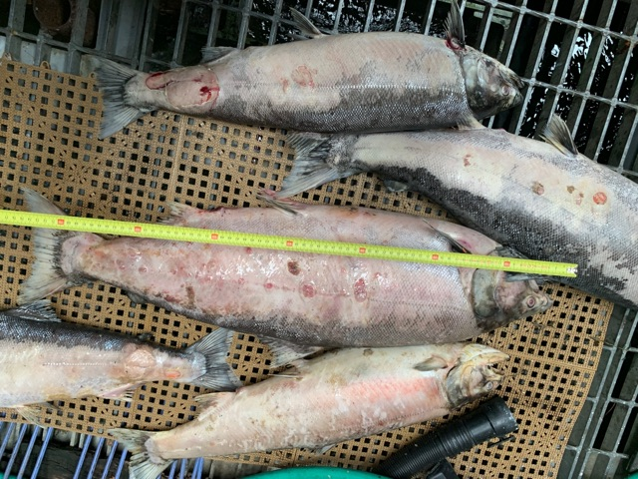Future and Preventative Measures – None

Sincerely,

Bonneville Project Fisheries